**Finding possible mechanisms of action for the orphan drug** **Iobenguane I 131 using Tanimoto similarity score and Principal component analysis (PCA)**

Varun Ullanat ([varunullanat.bt17@rvce.edu.in](mailto:varunullanat.bt17@rvce.edu.in))

**1. Introduction**

Iobenguane, or MIBG, is an aralkylguanidine analog of the adrenergic neurotransmitter norepinephrine and a radiopharmaceutical. It acts as a blocking agent for adrenergic neurons. When radiolabeled, it can be used in nuclear medicinal diagnostic techniques as well as in neuroendocrine antineoplastic treatments. It is an orphan drug, used to treat Paraganglioma.

Tanimoto similarity score is a measure to calculate similarity between two chemical compounds given its fingerprints. It is a useful tool to find out similar molecules for a query molecule. Here Iobenguane I 131 is treated as the query molecule to find out possible mechanisms of action by comparing to similar molecules with known activity.

Principal Component Analysis, or PCA, is a dimensionality-reduction method that is often used to reduce the dimensionality of large data sets, by transforming a large set of variables into a smaller one that still contains most of the information in the large set. PCA is done on the query molecule and target molecule to find out hidden similarities between them.

All coding was done using Python. The molecules were obtained from the ZINC database.

**2. Experimental design**

**2.1 Tanimoto similarity calculation**

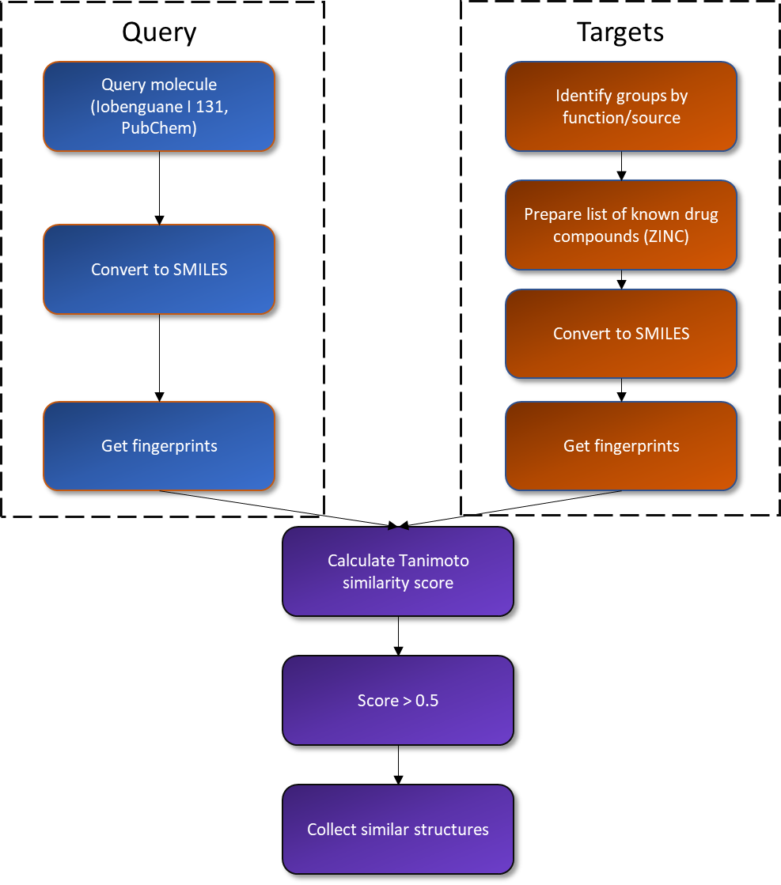

**2.2 Principal component analysis**

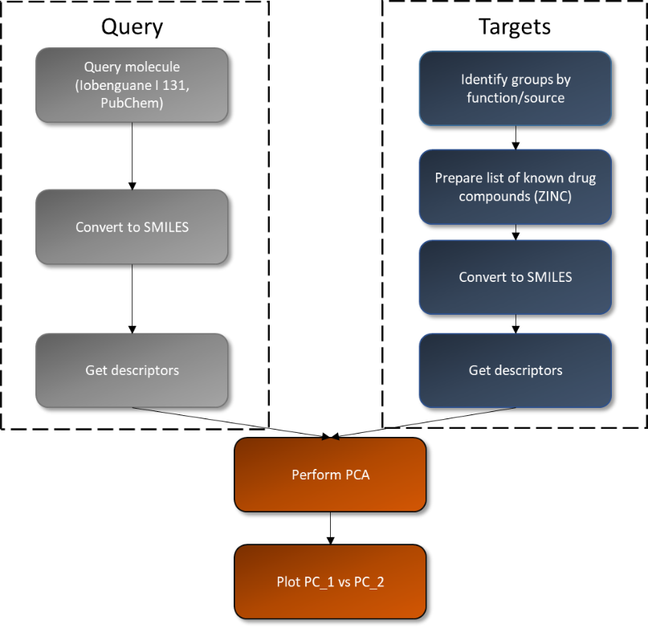

**3. Results**

**3.1 Targets groups**

|  |  |  |  |
| --- | --- | --- | --- |
| **Group** | **Description** | **Sub-groups** | **Number of molecules identified** |
| Biological targets | Substances/drugs that target biological molecules | Enzyme | 3,10,191 |
| Ion channel | 25,376 |
| Transporter | 32,115 |
| Transcription factor | 27,586 |
| Membrane receptors | 2,17,943 |
| Metabolites | Substances which are produced during metabolism | Primary metabolites | 81,519 |
| Secondary metabolites | 2,24,205 |
| FDA approved | Drug substances approved by the Food and Drug Administration | Commercial | 1,615 |

**3.2 Biological targets with similarity > 0.5**

**3.2.1 Enzyme targeting drugs (First 4)**

|  |  |  |  |
| --- | --- | --- | --- |
| **ZINC ID** | **SMILES** | **Tanimoto similarity score** | **Molecular structure** |
| ZINC000087515328 | O=CNCc1ccccc1 | 0.516340 |  |
| ZINC000053084618 | C#CCN(C)Cc1ccccc1 | 0.550898 |  |
| ZINC000026651414 | C#CCN(N)Cc1ccccc1 | 0.522727 |  |
| ZINC000026647798 | C#CCNNCc1ccccc1 | 0.503067 |  |

**3.2.2 Ion-channel targeting drugs**

|  |  |  |  |
| --- | --- | --- | --- |
| **ZINC ID** | **SMILES** | **Tanimoto similarity score** | **Molecular structure** |
| ZINC000000084096 | O=C(NCc1ccccc1)NCc1ccccc1 | 0.585366 |  |

**3.2.3 Transporter targeting drugs**

|  |  |  |  |
| --- | --- | --- | --- |
| **ZINC ID** | **SMILES** | **Tanimoto similarity score** | **Molecular structure** |
| ZINC000002390011 | C[C@@H](N)Cc1ccc(I)cc1 | 0.516854 |  |
| ZINC000003619527 | C[C@H](N)Cc1ccc(I)cc1 | 0.516854 |  |
| ZINC000002390011 | C[C@@H](N)Cc1ccc(I)cc1 | 0.516854 |  |
| ZINC000003619527 | C[C@H](N)Cc1ccc(I)cc1 | 0.516854 |  |

**3.2.4 Transcription factor targeting drugs**

No substances with similarity > 0.5 with Iobenguane I 131

**3.2.5 Membrane receptor targeting drugs (First 4)**

|  |  |  |  |
| --- | --- | --- | --- |
| **ZINC ID** | **SMILES** | **Tanimoto similarity score** | **Molecular structure** |
| ZINC000029132760 | Ic1cccc(CN2CCN(CCCc3ccccc3)CC2)c1 | 0.505155 |  |
| ZINC000013736089 | c1ccc(CNCCCCCC2CCCCC2)cc1 | 0.535912 |  |
| ZINC000022940262 | CN(CCN1CCCC1)Cc1cccc(I)c1 | 0.544747 |  |
| ZINC000002013275 | N=C(NCc1ccccc1)NCc1ccccc1 | 0.721854 |  |

**3.3 Metabolites with similarity > 0.5**

**3.3.1 Primary metabolites (First 4)**

|  |  |  |  |
| --- | --- | --- | --- |
| **ZINC ID** | **SMILES** | **Tanimoto similarity score** | **Molecular structure** |
| ZINC000000967716 | c1ccc(Nc2ccccc2)cc1 | 0.508929 |  |
| ZINC000002032473 | C[C@@H](c1ccccc1)N(C)C | 0.573964 |  |
| ZINC000004271722 | SCCc1ccccc1 | 0.508772 |  |
| ZINC000000895323 | O=CCc1ccccc1 | 0.513514 |  |

**3.3.2 Secondary metabolites (First 4)**

|  |  |  |  |
| --- | --- | --- | --- |
| **ZINC ID** | **SMILES** | **Tanimoto similarity score** | **Molecular structure** |
| ZINC000000167189 | CC[C@@H](C)N=C=S | 0.516129 |  |
| ZINC000013376404 | OCSCc1ccccc1 | 0.513274 |  |
| ZINC000000869715 | O=C(NCCc1ccccc1)c1cccc(I)c1 | 0.532609 |  |
| ZINC000015205244 | CC[C@@H](CCO)C(C)C | 0.523810 |  |

**3.4 FDA approved**

**3.4.1 Purchasable**

No FDA approved drug with similarity > 0.5 with Iobenguane I 131

**3.5 Final similarity table**

|  |  |  |  |  |
| --- | --- | --- | --- | --- |
| **Group** | **Description** | **Sub-groups** | **Number of molecules with similarity > 0.5** | **Highest similarity score** |
| Biological targets | Substances/drugs that target biological molecules | Enzyme | 37 | 0.550898 |
| Ion channel | 1 | 0.585366 |
| Transporter | 4 | 0.516854 |
| Transcription factor | 0 | NA |
| Membrane receptors | 14 | 0.721854 |
| Metabolites | Substances which are produced during metabolism | Primary metabolites | 18 | 0.573964 |
| Secondary metabolites | 8 | 0.537572 |
| FDA approved | Drug substances approved by the Food and Drug Administration | Commercial | 0 | NA |

**3.6 PCA plots**

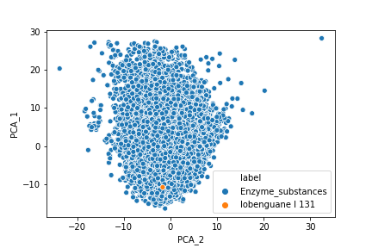 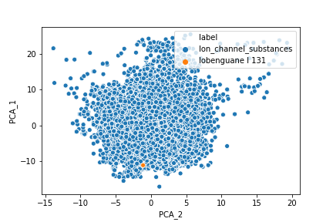

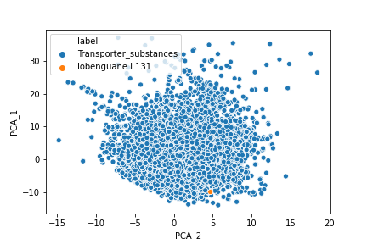 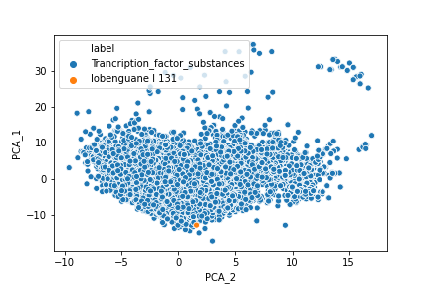

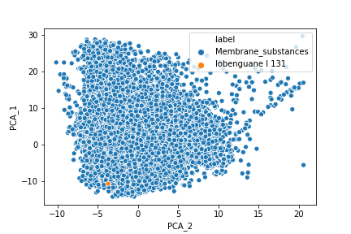 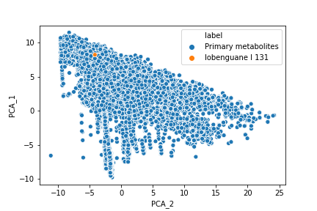

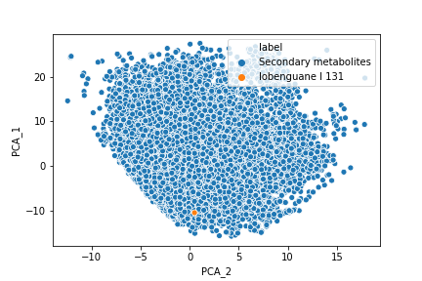 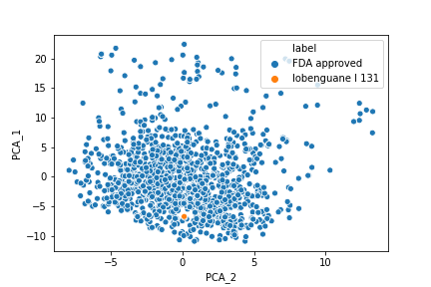

**4. Conclusion**

From the Tanimoto similarity score of all the target groups in Section 3.5, it appears that query molecule Iobenguane I 131 is similar to drugs that target enzymes and membrane receptors. By looking at the PCA plots in Section 3.6, it is also evident that the query molecule is most similar to primary metabolites found in the human body and has signatures similar to FDA approved drugs. **Thus, we can conclude that the orphan drug** **Iobenguane I 131 is similar to a primary metabolite found in humans and it targets an enzyme or a membrane receptor.**

This is proved to be correct, as Iobenguane I 131 is similar to the neurotransmitter norepinephrine (NE), a primary metabolite that acts on membrane receptors. The method thus provides chemists with an effective way to find out the mechanism of action and/or targets of drugs whose activity is unknown.